Financial Engineering Lab-6

*Only some representative plots included here. All plots stored in “plots” folder question-wise in pdf files.

Stock Tickers Used -
Included in the index - BHARTIARTL, HDFCBANK, HINDUNILVR, ITC, KOTAKBANK, MARUTI, NESTLEIND, RELIANCE, SBIN, TCS
Not Included in the Index- AMBUJACEM, ASHOKLEY, BHEL, BOSCHLTD, MRF, PETRONET, PIDILITE, SIEMENS, TATAGLOBAL, TVSMOTOR
I have Used stocks which are both present in SENSEX and NIFTY 50 and the stocks not included are not present in both indices.

Question 1

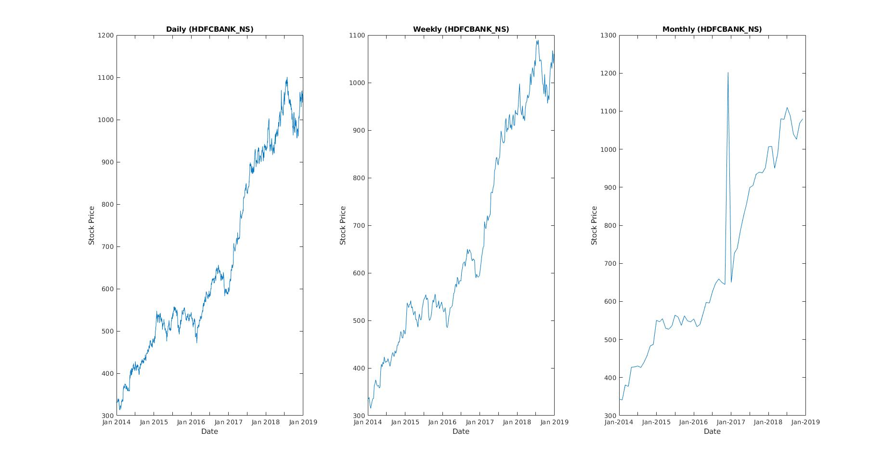
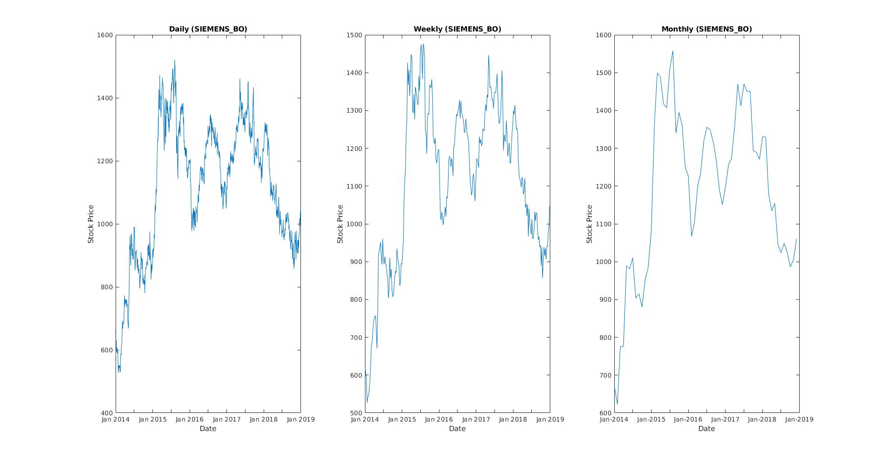

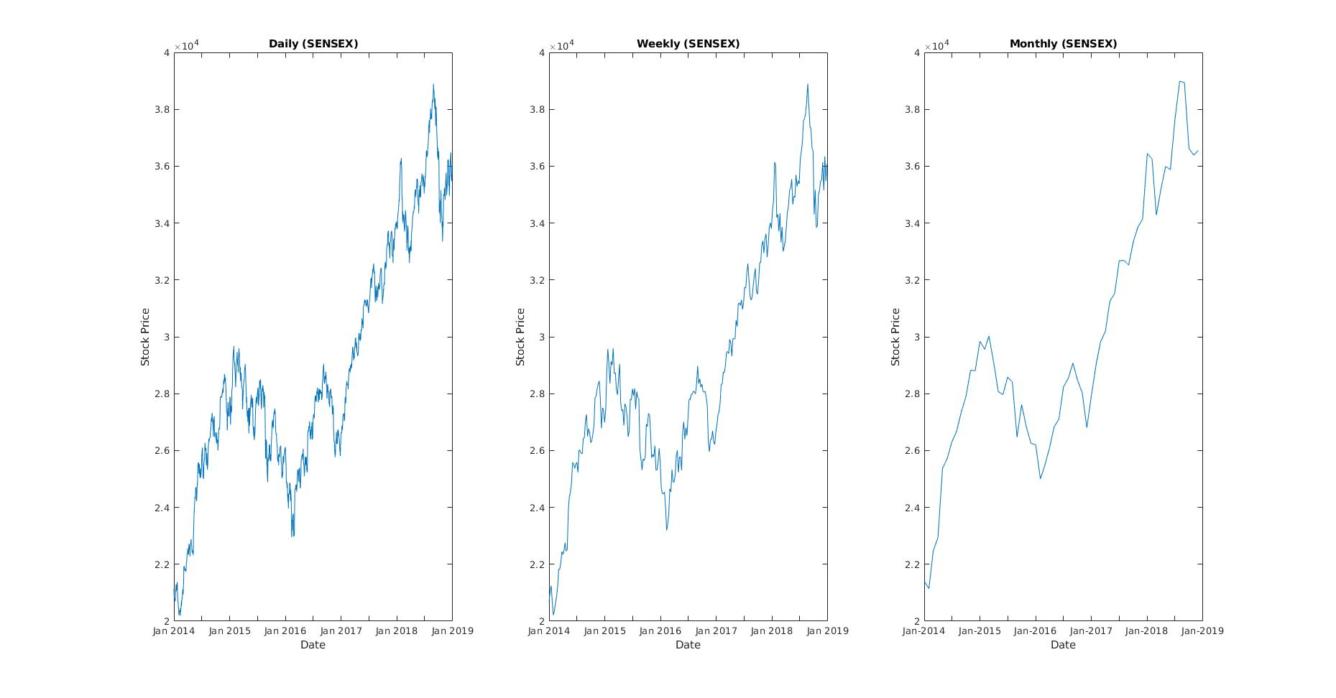
Question 2
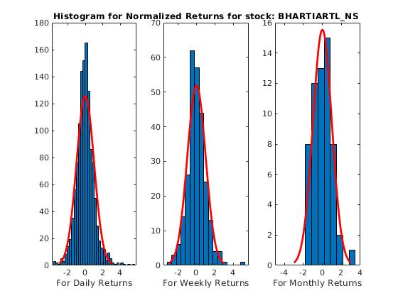

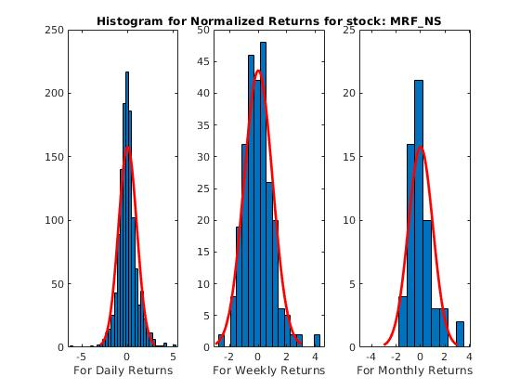
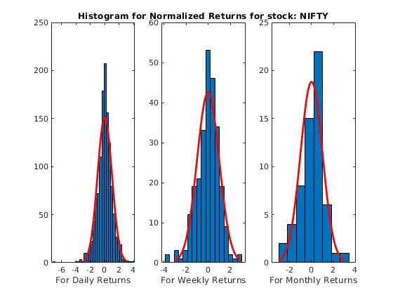

After observing the plots, we see that some of the plots are tail heavy and deviate from the assumption that stock returns follow normal distribution. The cause for this deviation could be fluctuations in the market which can’t be incorporated in the distribution.

Question 3
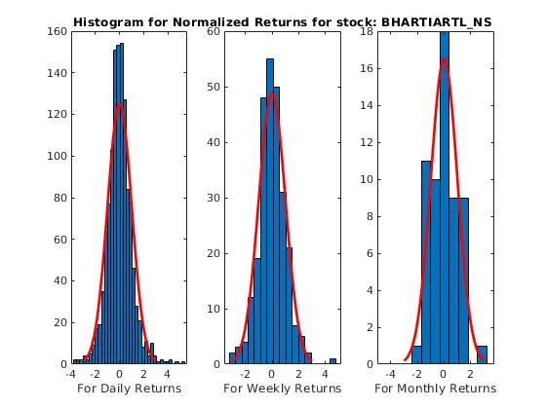

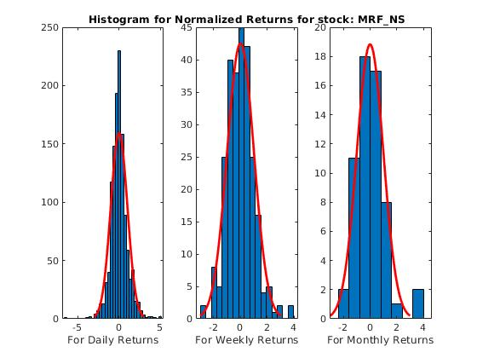

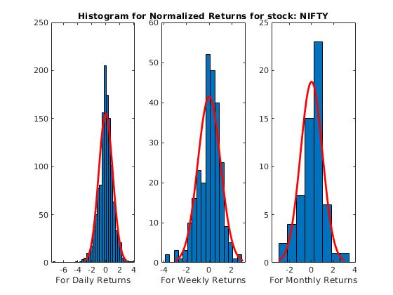

Question 4

Assuming that the stock will follow a Geometric Brownian Motion, we generate stock prices for 2018 using the µ and σ from 2014-2017 data .
S(t) = S(0)*exp{σ*W(t) + (µ -σ²/2)*t }
where W(t) is a brownian Motion. Therefore W(t) ~ Ɲ(0,t).

t =1/246,2/246.......... (for daily prices)

t=t =1/52,2/52.......... (for weekly prices)

t =1/12,2/12.......... (for Monthly prices)

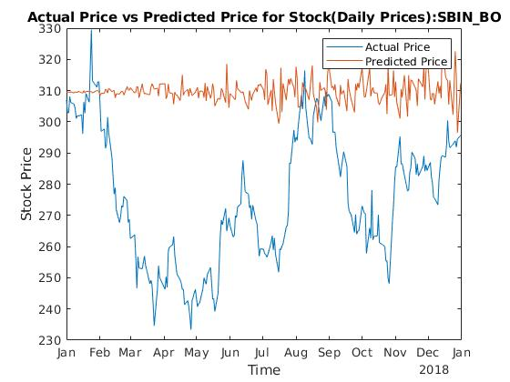

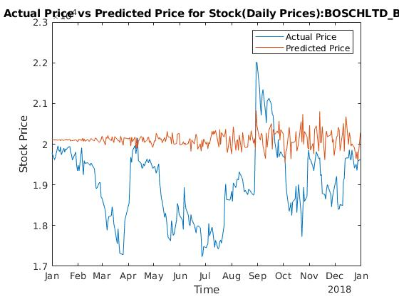

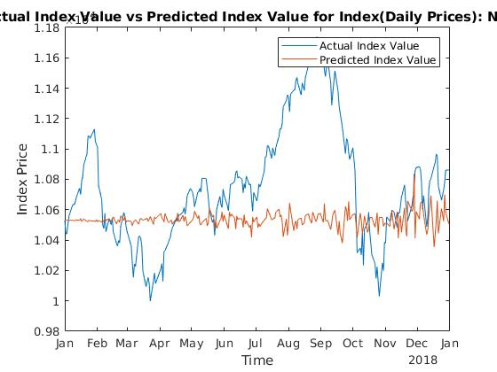

Question 5
